Pir Mehr Ali Shah

**Arid Agriculture University, Rawalpindi**

*Office of the controller of Examinations*

**Final Exam (Theory) / Spring 2021 (Paper Duration 12 hours)**

**To be filled by Teacher**

Course No.: **CS-632** Course Title: **Artificial Intelligence**

Total Marks: **30** Date of Exam: **14-07-2021**

Degree: **BSCS** Semester: **6** Section: **B**

|  |  |  |  |  |  |  |  |  |  |  |  |
| --- | --- | --- | --- | --- | --- | --- | --- | --- | --- | --- | --- |
| **Q. No.** | 1 | 2 | 3 | 4 | 5 | 6 | 7 | 8 | 9 | 10 | Marks  Obtained/  Total Marks |
| **Marks**  **Obtained** |  |  |  |  |  |  |  |  |  |  |  |

|  |
| --- |
| **Total Marks in Words:** |
| **Name of the teacher:** |
| **Who taught the course: Signature of teacher / Examiner:** |

**To be filled by Student**

**Registration No.: 18-ARID-2707 Name: Sayed Yasir Mehdi**

**Answer the following questions.**

**Question No. 1: [6]**

“A* search performs better than Greedy best first”.

1. Comment on this statement and justify your answer.
2. How a classification problem is different from clustering? Justify your answer with the help of an example.

**Ans:**

**A:**

Both methods are "Best First Search" algorithms, which are algorithms that can use both the information obtained so far while searching for a search location, indicated by the G (N), and h (to estimate). A horoscope function described by n) can be used. The distance of the round node for each node n in the search space.

The greedy BFS is not complete, not maximal, and has a complexity of times (B ^ m) and a space that can be multiple. A * is complete, maximal, and O (b ^ m) is the complexity of time and space. In general, A * greedy uses more memory than BFS. When the search space is wide, A * becomes unusable. A *, on the other hand, guarantees that the path discovered between the start node and the destination node is the best, and that the algorithm eventually ends. The greedy BFS, on the other hand, uses less memory but does not guarantee the maximum of A *.

If the horoscope function is acceptable, which indicates that it never exceeds the cost of achieving the goal, then the A * algorithm is maximized and completed. In this case, the A * algorithm advances the greedy search method.

**B:**

Clustering has been developed in the context of irregular learning. That is, for such an algorithm, we only have a labeled input data about which we will know what the output will be without knowing what will be collected.

Clustering is used by businesses that want to identify commonalities among their customers in order to implement customer segmentation, develop customer travel maps, or locate groups and focus on products and services. can go. Thus, if a large number of clients have certain characteristics (age, family type, etc.), the firm may justify a particular campaign, service or product. Clustering can also be used to provide broad insights and information.

On the other hand, ranking monitoring is learning, which shows that we know the input data (labeled in this case) and the potential output of the algorithm. Here is the binary classification, which responds to clear response classes (such as "yes" and "no") that respond to problems with ambiguous classes and more open answers such as "open", "regular", and multicast issues. ۔ ", And" insufficient ".

Rating is used to identify spam in a number of articles, such as biology or Dewey Decimal classification, or email.

**Example:**

**Fraud detection:**

In the banking industry, fraud detection classification is widely used. In the age of online shopping, when the use of cash has declined significantly, it is important to assess whether the card transaction is secure. In order to identify fraud, entities can use past data on consumer behavior to validate transactions or to classify fraud.

**Netflix**

Netflix is ​​a well-known implementation of the proposed system clustering algorithm. Although the corporation is highly confidential about its algorithms, it has been confirmed that there are approximately 2,000 clusters or groups with common audiovisual interests. Cluster 290 includes fans of the TV shows "Pumpkin," "Moneyhost," and "Game of Thrones." Netflix uses these clusters to improve its understanding of audience preferences and, as a result, makes better decisions when new real-world applications are developed.

**Question No. 2: [8]**

Coral image dataset is a benchmark image dataset to test the various computer vision applications. It contains images of 100 categories, and there are 1000 images from diverse contents such as sunset, beach, flower, building, buses, horses, mountains, fish, food, elephant, etc. We have extracted some Gray Level Co-occurrence Matrix texture features from Coral image data set of elephant and horses class which are given below. You need to classify the image 9 using KNN algorithms, where k = 3.

**Note:** X1 is the last digit of your registration number, X2 is the second last digit and similarly X3 and X4. If there are three numbers in your arid number, then X4 will be zero.

|  |  |  |  |  |  |
| --- | --- | --- | --- | --- | --- |
| Image | Homogeneity | Correlation | Contrast | Energy | Image Class |
| Image 2 | 2.1 | 3.6 + 7=10.6 | 4.4 | 5.1 | Horse |
| Image 3 | 0.4 | 1.3 | 2.5 | 3.3 | Elephant |
| Image 4 | 2.3 + 0=2.3 | 2.6 | 2.6 | 2.1 + 7=9.1 | Elephant |
| Image 5 | 3.3 | 3.3 | 3.4 – 7=-3.6 | 3.1 | Horse |
| Image 6 | 4.2 | 2.1 | 4.2 | 4.3 | Horse |
| Image 7 | 2.2 | 2.3 | 2.5 | 2.6 | Horse |
| Image 8 | 3.9 | 2.5 | 3 | 2.5 | Elephant |
| Image 9 | 3.1 + 2=5.1 | 2.1 | 2.2 | 4.2 – 7=-2.8 | ? |

Ans:

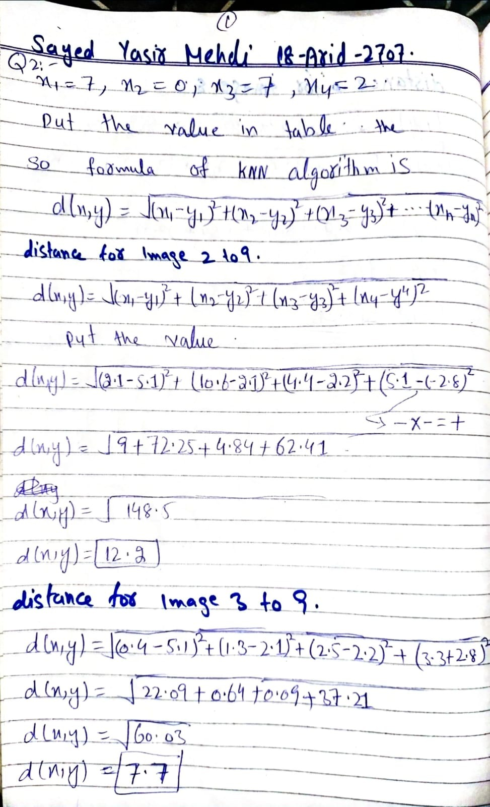

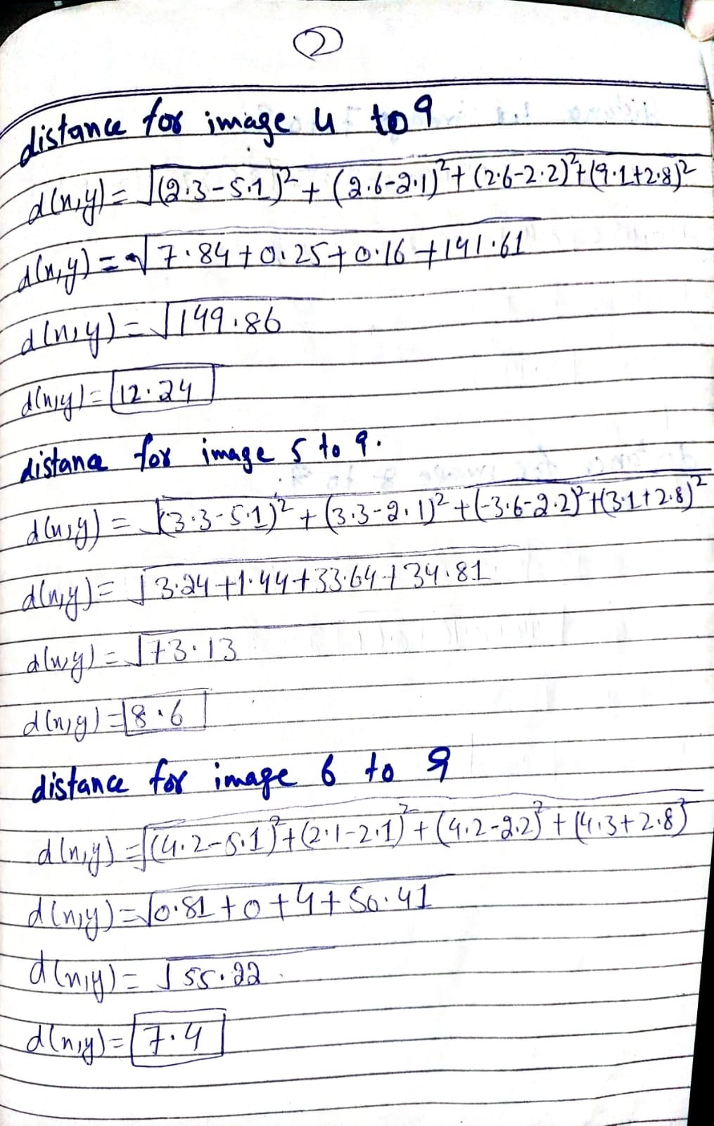

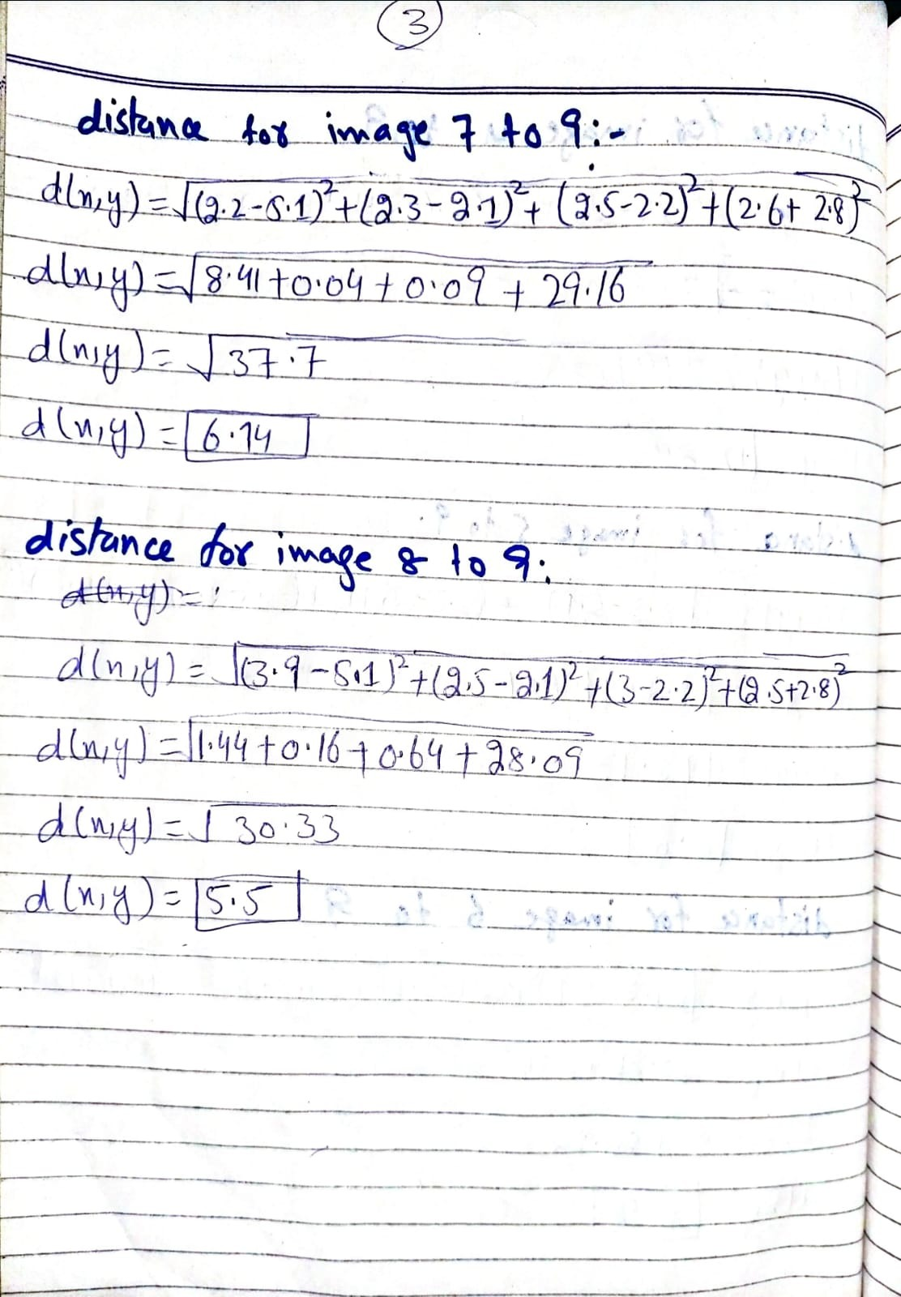

**Question No. 3: [8]**

Consider a set of data points {(-10, 13, 10), (-6, 9, 5), (-6, 17, 9), (-2, 13, 10), (-3, 0, 5), (10, 15, 13)}. Add last two digits of your registration number with each given value. For example, if last two digits of your registration number are 14 then first point will be (-10+14, 13+14, 10+14) = (4, 27, 24). Use the k-means clustering procedure with k = 3 to group these data points. Start with the three initial cluster centers: (-6, 9, 5), (-2, 13, 10), (10, 15, 13). Show your working for 2 iterations. Use D = $\sqrt{{(x_{i}-y_{i})}^{2}}$ for distance calculation.

**Ans:**

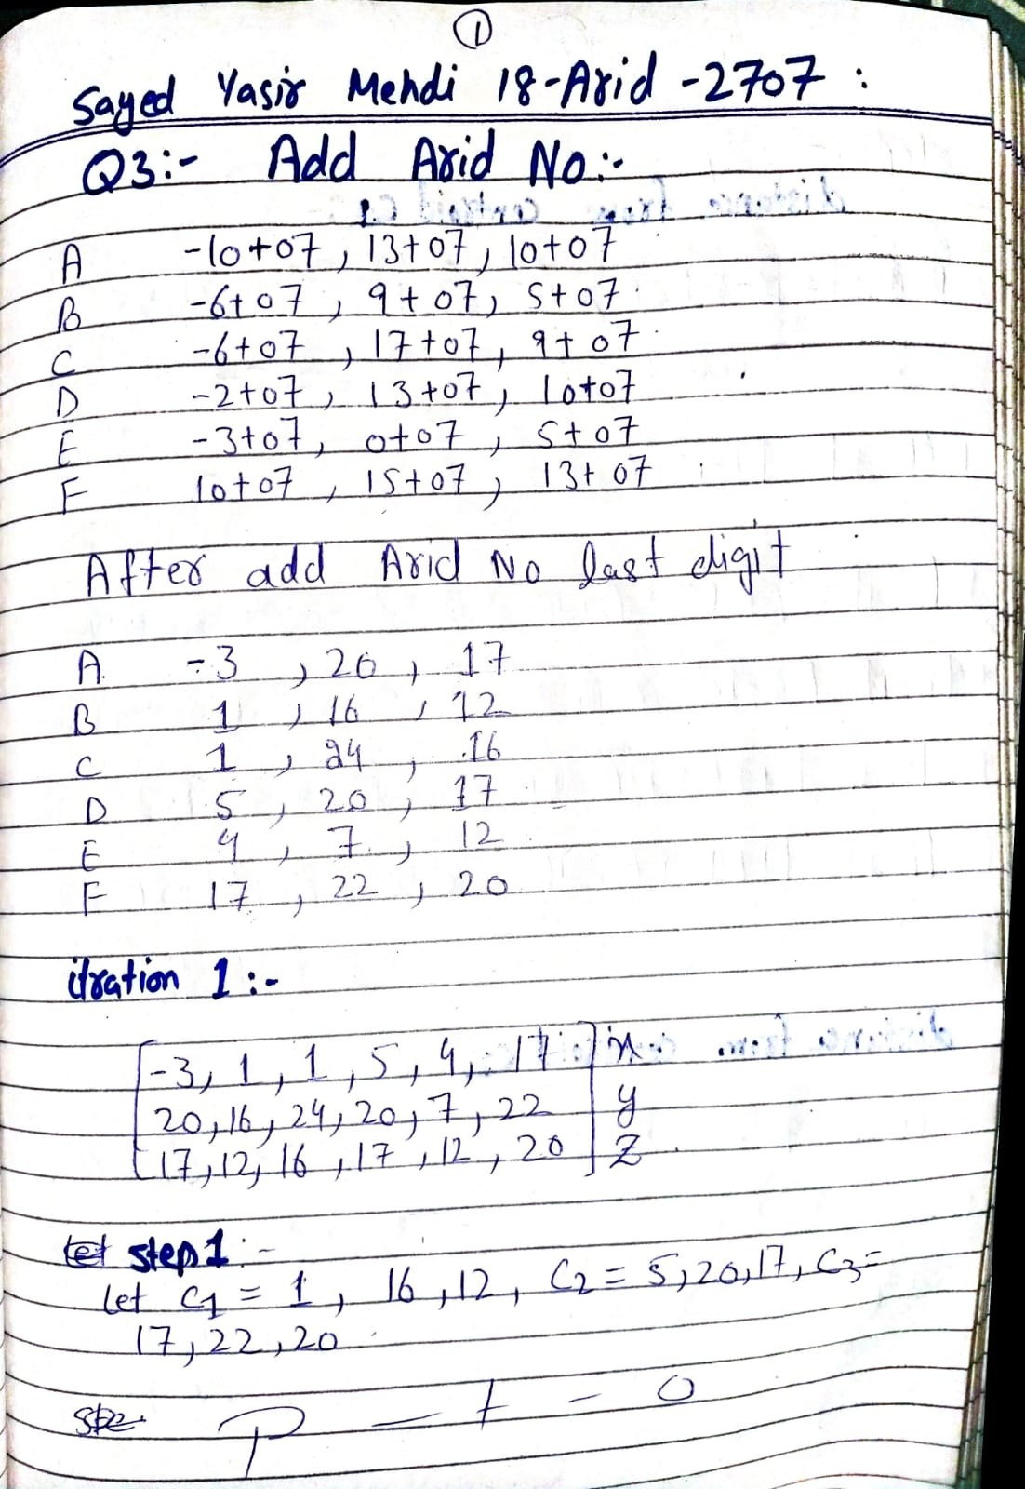

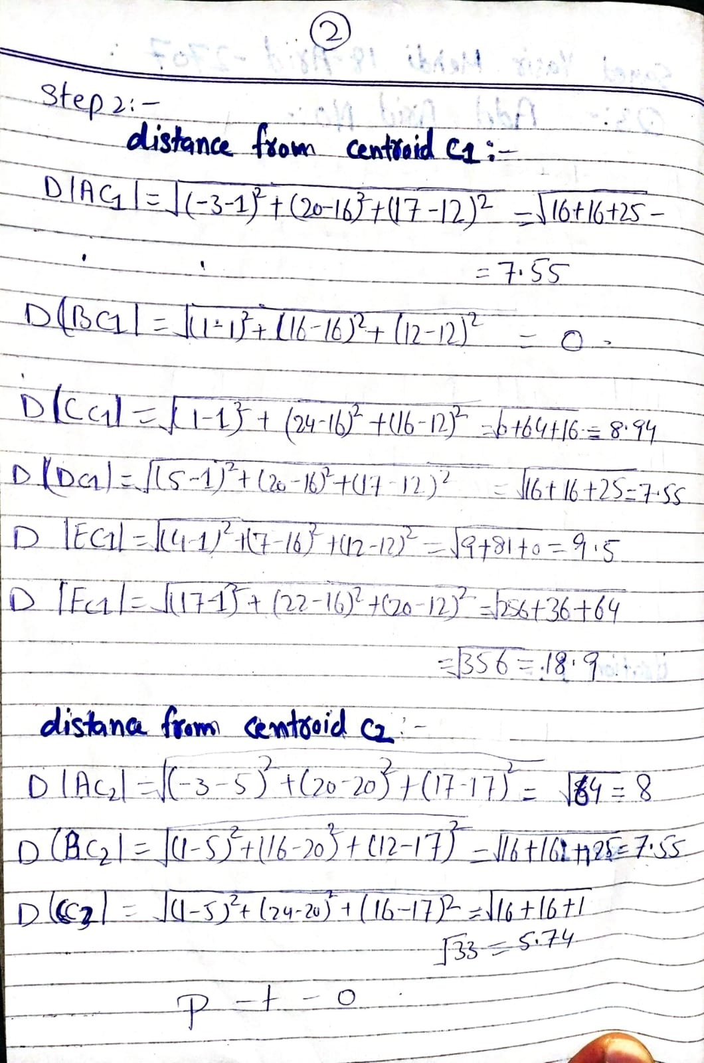

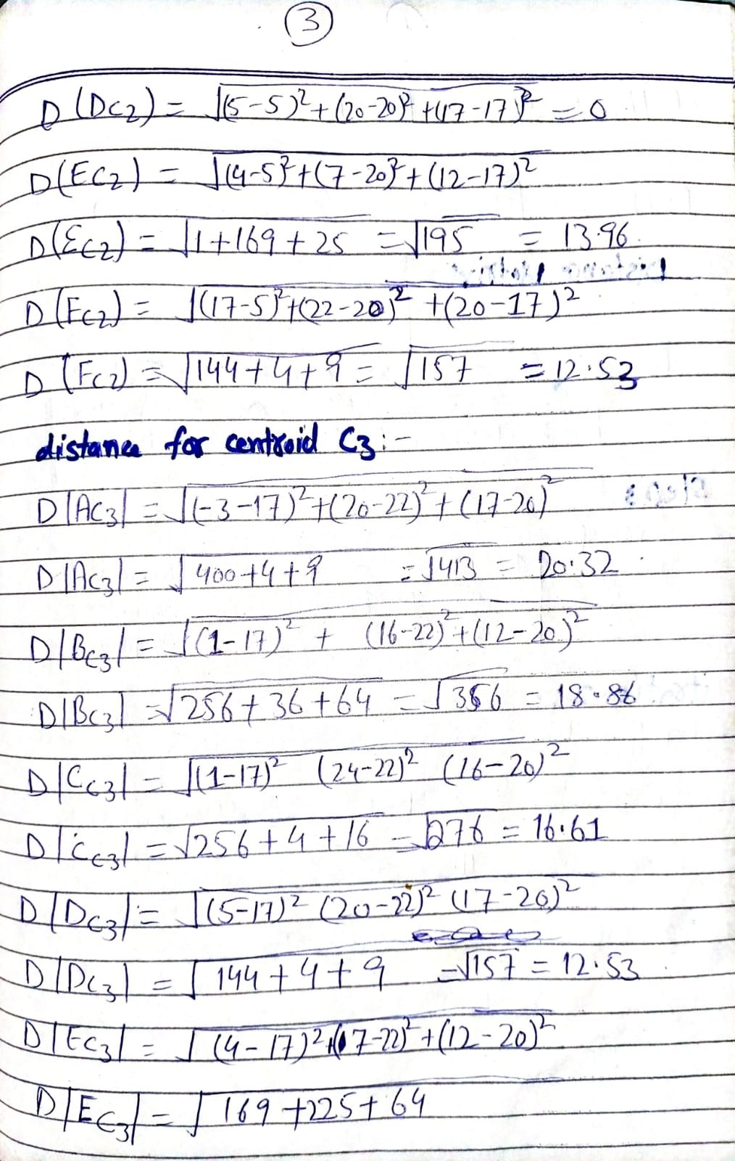

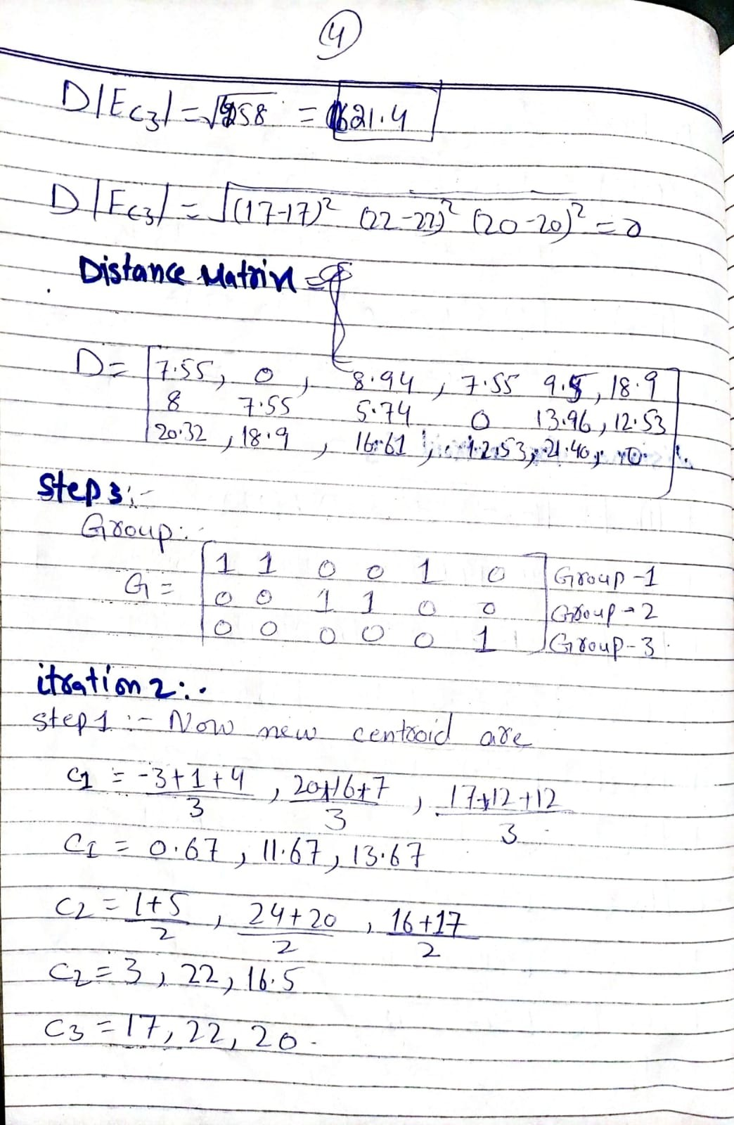

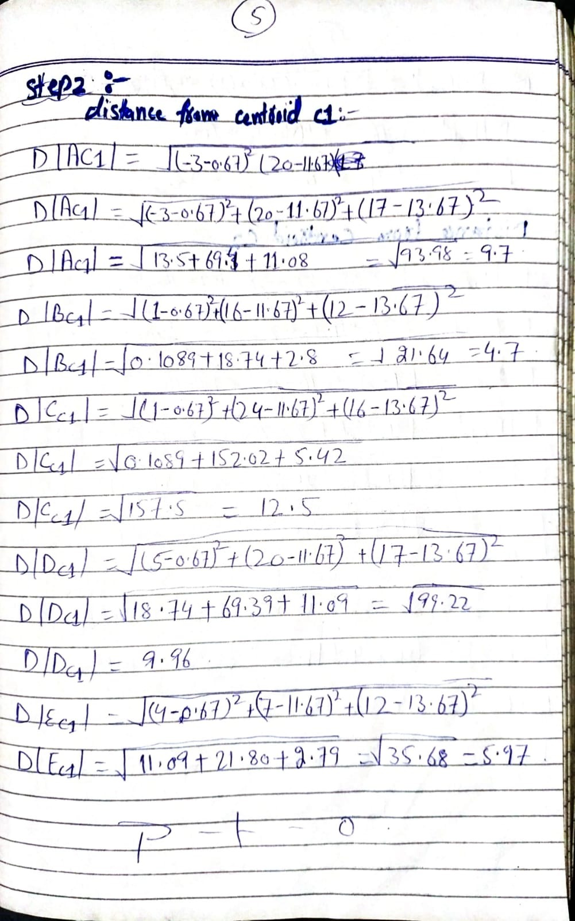

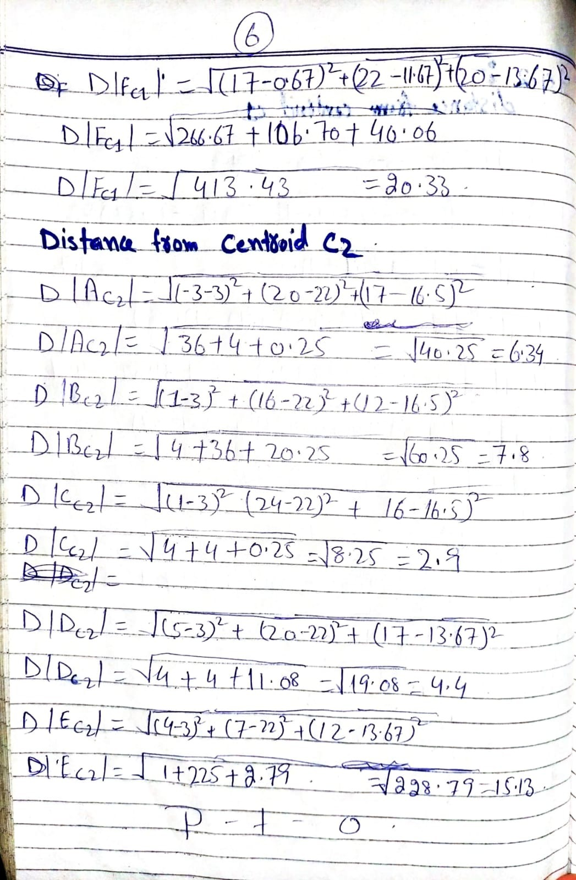

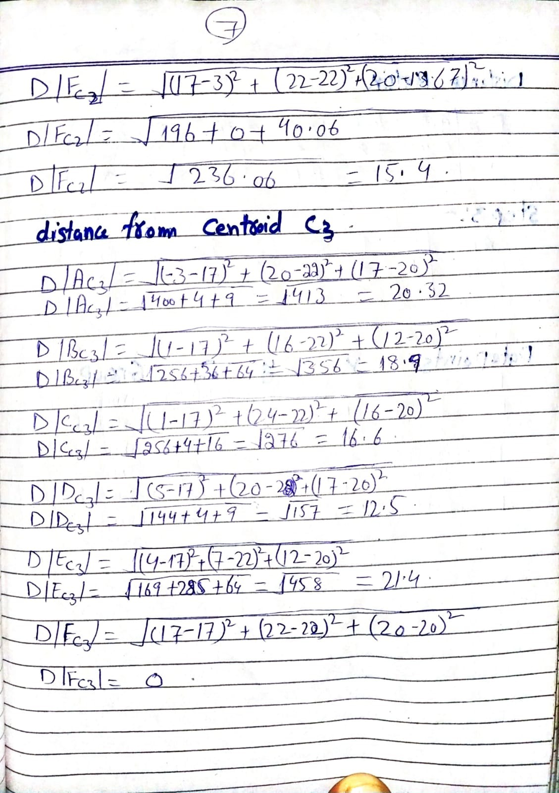

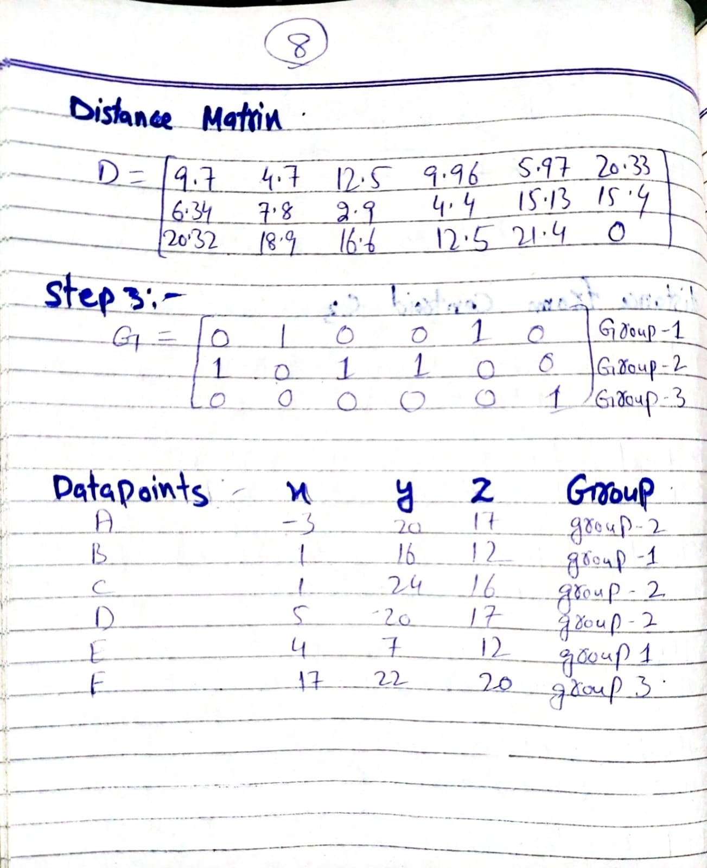

**Question No. 4: [8]**

Consider the following data with Result as class label and apply decision tree algorithm to decide the

root node. You are required to compute the following:

1. Compute the Entropy of “Result”.
2. Compute Information Gain of Short Attendance, Employment Status and Gender.
3. Identify the root node based on information gain.

|  |  |  |  |  |
| --- | --- | --- | --- | --- |
| ***Student ID*** | **Short Attendance** | **Employment Status** | **Gender** | **Result** |
| 2080191 | No | Jobless | Male | Fail |
| 2080192 | Yes | On Job | Male | Pass |
| 2080193 | Yes | Jobless | Female | Fail |
| 2080194 | No | On Job | Female | Fail |
| 2080195 | Yes | Jobless | Female | Pass |
| 2080196 | Yes | On Job | Male | Fail |
| 2080197 | No | Jobless | Male | Fail |
| 2080198 | Yes | Jobless | Female | Pass |
| 20801919 | Yes | On Job | Male | Fail |
| 20801920 | Yes | Jobless | Male | Pass |

**Ans:**

**A:**

**Description of Given dataset in Rapid Miner:**

Short Attendance = No: Fail {Fail=3, Pass=0}

Short Attendance = Yes

| Employment Status = Jobless: Pass {Fail=1, Pass=3}

| Employment Status = On Job: Fail {Fail=2, Pass=1}

No of instance of fail =6

No of instance of pass= 4

Entropy (Result) = -6/10*Iog2 (6/10) + -4/10*Iog2 (4/10)= 0.97

**B:**

**Information Gain of Short Attendance:**

**Entropy** (Result | Short Attendance) =3/10*Entropy (Result | Short Attendance=No )+ 7/10*Entropy (Result | Short Attendance =yes )

= 0.3* [ -3/3Iog2(3/3) + -0/3Iog2 (0/3) ] +0.7*[- 4/7 Log2 (4/7) - 3/7Iog2 (3/7) ]= **0.68**

**Information Gain** (Short Attendance) = Entropy (Result) - Entropy (Result | Short Attendance)

= 0.97 - 0.68 = **0.29**

**Information Gain of Employment Status:**

Entropy ( Result | Employment Status) =6/10“Entropy ( Result | Employment Status=JobIess ) + 4/10*Entropy ( Result I Employment Status =On job )

= 0.6* [ -3/6Iog2 (3/6) + -3/6Iog2 (3/6) ] +0.4*[- 3/4Iog2 (3/4)- 1/4Iog2 (1/4) ]= **0.92**

**Information Gain (Employment Status)** = Entropy (Result) - Entropy (Result |Employment Status = 0.97- 0.92 = **0.05**

**Information Gain of Gender:** Entropy (Result | Gender) =6/10*Entropy ( Result | Gender=MaIe ) + 4/10*Entropy ( Result | Gender=FemaIe)

= 0.6* [ -4/6Iog2 (4/6) + -2/6Iog(2/6) ] +0.4*[- 2/4Iog2 (2/4) - 2/4Iog2 (2/4) ]

= 0.55 + 0.4

**= 0.95**

**Information Gain (Gender)**

= Entropy (Result) - Entropy (Result |Gender)

= 0.97 - 0.95

**= 0.02**

**C:**

As the information gain for Short Attendance attribute is maximum so we will use it as a root node.

Root node= **Short Attendance**

**Screenshot:**

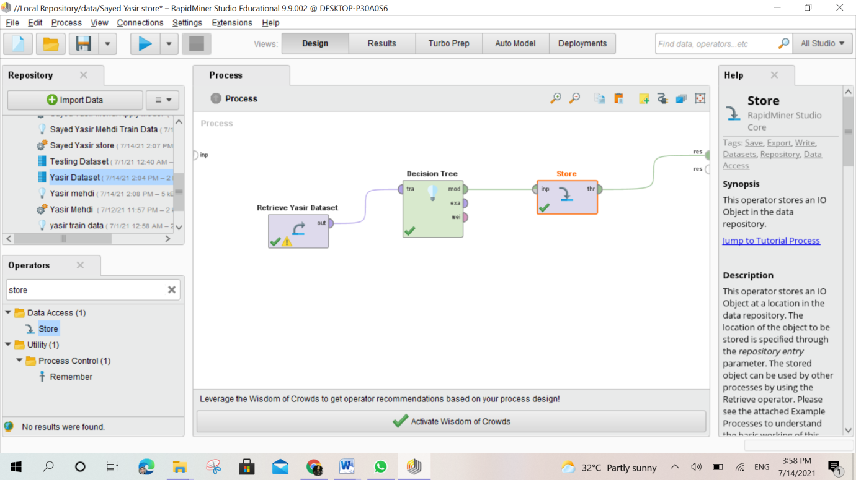

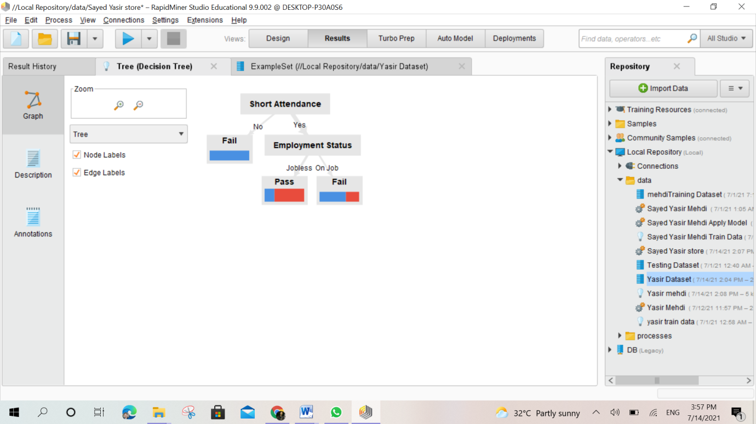

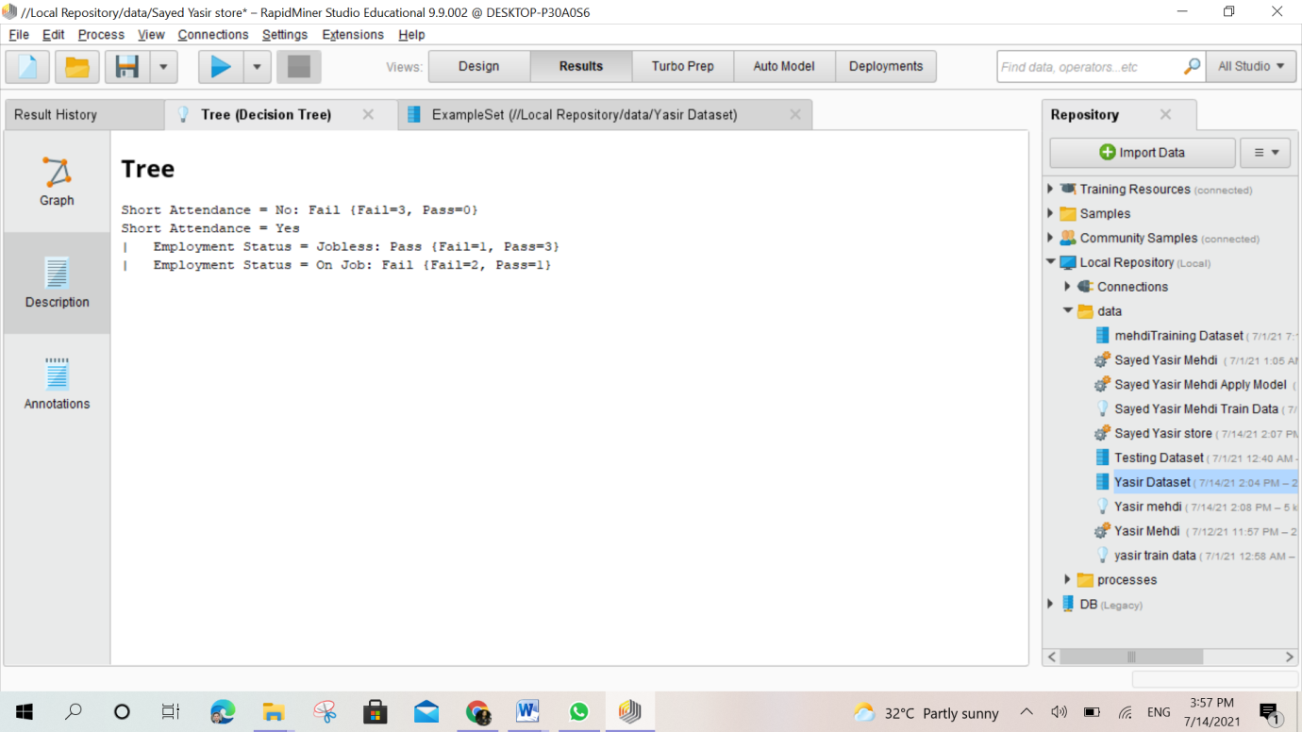

**Good Luck**